Single player Designer: Davis Bakker
Raven Single-Player Design Test High Level Pitch
“Airspace”
OBJECTIVE: Design and build a single-player level for Call of Duty: Black Ops 3.
Deadline: end of day on 7/1/21
genre
- FPS
Locations
- Overarching: Singapore
- Path:
  - Marina bay circuit (turned refugee camp after the explosion)
  - Singapore flyer
  - ECP overpass
  - Marina bay sands (lobby – one of the immortals bases)
  - Marina bay sands (roof – drone flight control center)
what will be unique about the level
- Timed waves of drones sweeps through the area dealing massive damage to the player if they are caught outside when the timer hits zero. This will repeat consistently until the player has disabled the drone flight system on Marina Bay Sands’ rooftop
- The introductory sections of this level will allow for stealth
- Multilane level design allows for the player to chose any number of routes through the level as well as allowing the player to chose how much combat the player wants to be involved in.
- High population area, as a prelude to the massacre at the end of Hypocenter, there will be a number of civilians that are beginning to be harassed and assaulted in this area as well as attacked by the drones to further exemplify that the drone threat needs to be dealt with.
- Primarily close quarters environments with the level layout opening up only when the player gets to the Roundabout section of the map means CQC weapons will be the most beneficial (for the most part) with only areas like the street being more open to ranged weapons
game storyline
- This level takes place between the levels of “Provocation” and “Hypocenter” and acts as the bridge for how the player manages to get to hypo center from the attack at the Immortal base while also representing the vicious nature of the immortals before they fall to complete populous massacre tactics in the latter levels.
- Intro: On their way to the Hypocenter facility the player begins intercepting a variety of communications from the immortals leader via radio on the stolen airboat the player acquired. The remaining leader wants to lock down the deadzone and kill the CIA dogs using everything method available to them. The leader states to release “Locust” a number of the old age drones that lost use after the creation of the DEAD systems utilized by many cities. These drones are strafing the city in an attempt to kill all CIA forces. The Players boat is identified and attacked by the drones crashing it on the chore under the cover of an overpass. This is where the level begins.
game play description:
- The player will wake upon the shore of the marina bay circuit next to the crashed boat. The player is then informed by command that there the CIA forces are under attack all across the city by a drone force and the sweeps of the drones are taking out any non immortals they find out. (implying heavy civilian casualties) This is further exemplified when you see some civilians get gunned down in the open area just outside of the overpass’ protective covering.
- The player then begins to infiltrate the Marina bay circuit trying to be stealthy (though not specifically necessary) as more and more Immortals begin searching the buildings for you as the drones have notified their forces as to the crash location of the speed boat.
- Entryway: The player can then choose to go one of three different ways:
  - along the street on the left side where the immortals and civilians are stockpiling resources to survive off of in the slum, where the player can use the cargo and the vehicles as cover or cut into the garages to hide from the drones.
  - over the ramp leading up the building area to the top floor where the immortals have taken residence inside giving the player the chance to attack them and work their forward using vertical superiority.
  - under the ramp and up the stairs to find the living area for many of the civilians leaving it very close quarters but completely safe as that no civilians attempt to attack you.
    - Any of the latter 2 areas could include assassination opportunities available to the player to take down guards stealthily
- (All three areas can be reached after this point via the central staircase or a number of other paths leading between floors)
  - The top floor connects to the collapsed section of the building via a control area at the top right as well as the staircase and collapsed walkway leading to the second floor.
  - The second floor connects to the collapsed room via the stairwell as well as the aft section of the survivor camp on the right side
  - The ground floor can be used to access the survivor camp via the garage, as well as the collapsed room via the street or the connecting office room
- Collapsed building:
  - Due to the collapsed nature of the area, it is largely open with only about half the area covered from drone strikes and a lot of areas that have to be reached via climbing or wall running.
  - The majority of cover will be broken guard rails, rubble or cargo unloaded from the trucks
- Survivor camp:
  - Cover is provided by the concrete structures and the multitude of tents left over from aid groups from before Singapore was abandoned
  - The sections of tents that are torn provide no coverage against the drone strikes so careful positioning is key when traversing the area.
- (the collapsed building area and the survivor camp are largely interconnected with multiple ways to traverse between them)
  - The collapsed room leads to the camp via the garage doors and scaffold on the right side
  - The collapsed room connects to the adjacent building’s first floor hallway and to the café on the second floor
  - The camp can lead into and around the concrete buildings ending up in the meeting/ construction area before opening up into the flyers’ roundabout.
- Adjacent Building:
  - The lower level office hallway and the upper café are completely disconnected from one another however each connects directly to the roundabout combat area
- Flyer Roundabout:
  - This area is supposed to be a shift from hiding to running as the player is perused by the immortal forces.
  - All areas coalesce into the roundabout where a number of troops from the immortals as well as 2 lesser mechs will automatically find and begin attacking the player
  - This area will act as a battle arena before the player has to fight into the flyer taking down a number of the forces before the drone strikes will intensify and force the player into the flyer
- Flyer:
  - (the drones will not attack in this section as it is entirely covered)
  - The player will have to make their way up the various floors of the flyer as more immortals stream in from below with a few sparce individuals on various floors need to be dealt with as you frantically attempt to make your way across to the overpass
  - They will go up one level via stairwell and another via climbing up rubble (see “hypocenter” after defeating the mech) before crossing to the center where the flyer loading zone is before fleeing out the other side
  - This whole are will be very linear and straight forward as the player will be under fire from enemy forces the entire time
- Event(not implemented):
  - As the player crosses the walkway to the overpass the drones begin flying in very close peppering everything before crashing into the bent flyer and causing it to collapse into the walkway missing the player and cutting off the enemies
  - (this is the point where the player is informed where the drones are being piloted from) The player will then hijack one of the immortal vehicles on the other side of the walkway and drive via cutscene to marina bay sands across the river as drones pepper and crash into the overpass in an attempt to hit you.
- Marina Bay Sands (not implemented):
  - After crashing the car into the lobby of the building the player will then be hidden from the drone strike as they fight to the roof top reached via elevator shaft cord.
  - Once on the roof the player has to kill the forces controlling the drones and shut the drones down
- Event:
  - After destroying the drone controls the drones begin to fall out of the sky crashing into the neighborhoods around causing fires and damage. This puts a damp tone on the victory but considering the alternative it is for the best. They are later picked up by a CIA helicopter and they set out to “hypocenter”.
Combat:
- Time limit
- Special enemies
  - Bruisers/suppression bots
  - mech
- Environmental hazards/debilities
  - Fire
  - Darkness
  - Water
Big Moments:
- getting hit by drones and crashing into the shore
- Drones killing civilians that are out in the open
- the flyer crashing after being hit by the drones
- fleeing the drones in a mad car chase.
Master Objective:
- shutdown the drone support system
Side/Bonus Objectives:
- Kill mechs
- Hold out on the overpass
Infill:
- Cut scene
- Drive in on vehicle
Exfill:
- Get picked up via helicopter on the roof of Marina bay sands
Important area Overview location:
- Easily identifiable building from walkway/ flyer/ visible in background
  - Marina bay sands
Design expectation examples(pictures):
Marina bay sands Hotel (lobby)
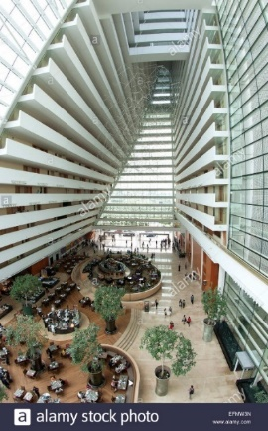
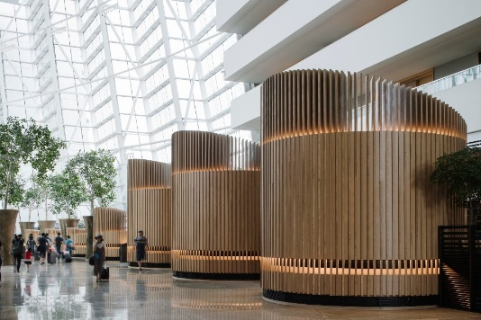
Marina bay sands Hotel (roof)
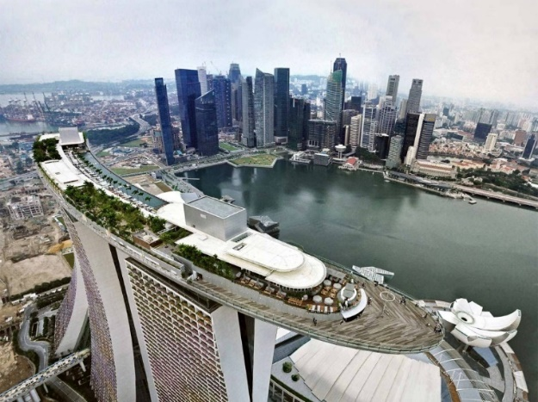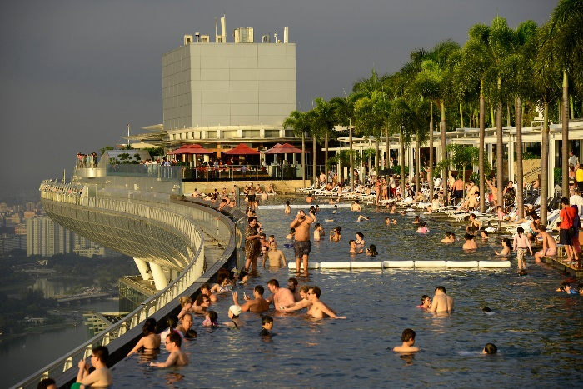
ECP overpass
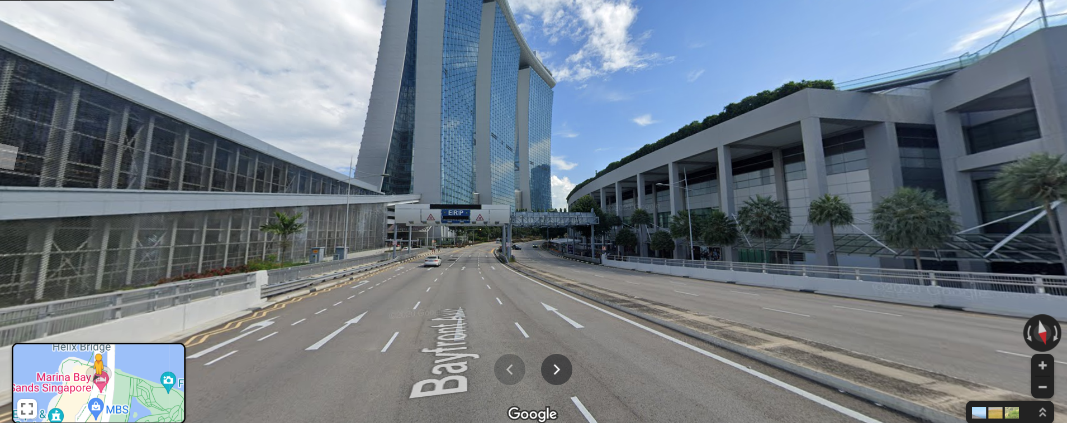
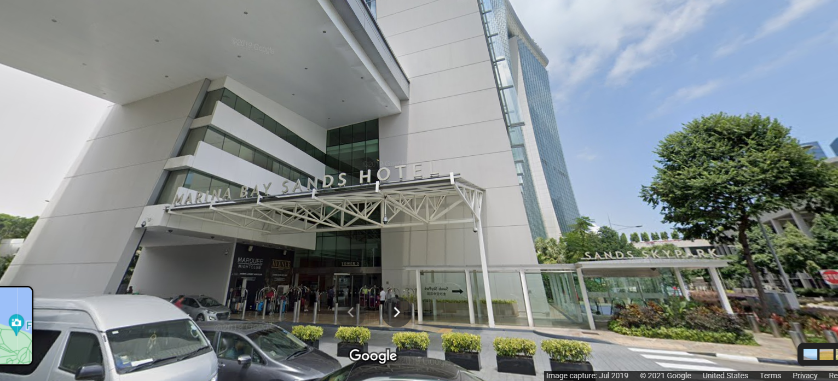
Singapore Flyer
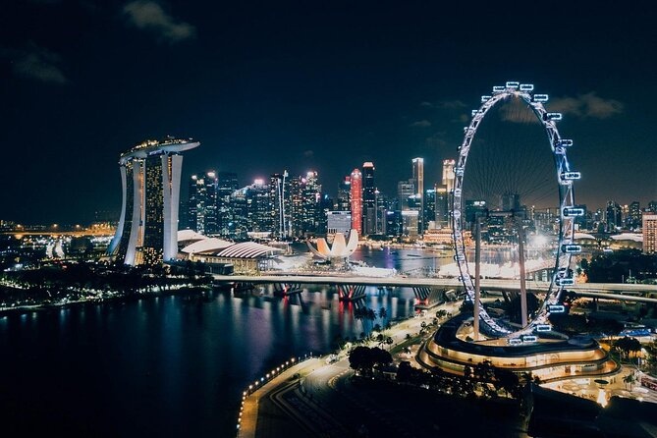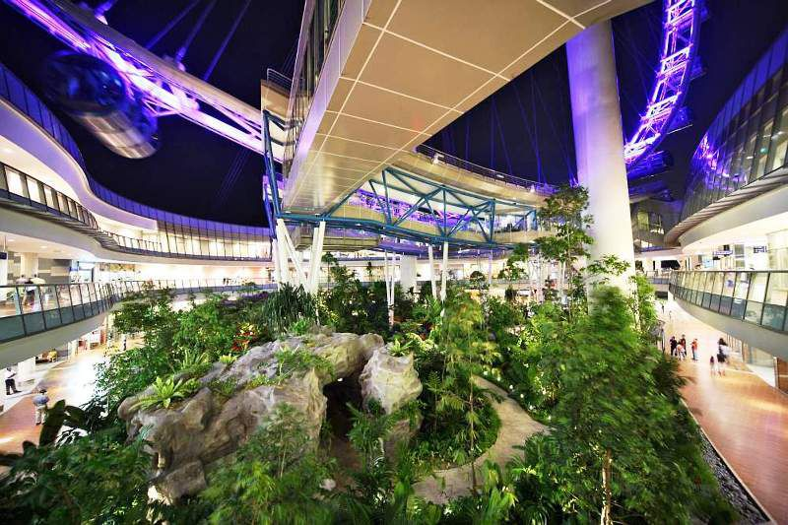
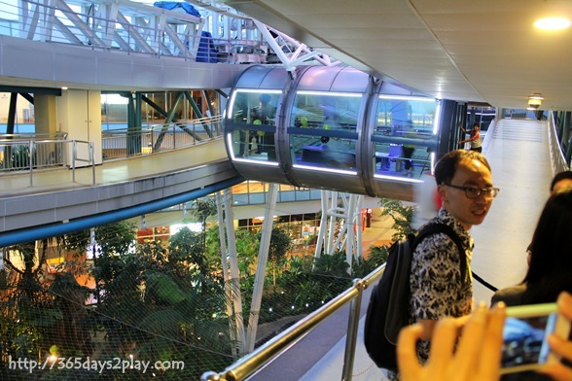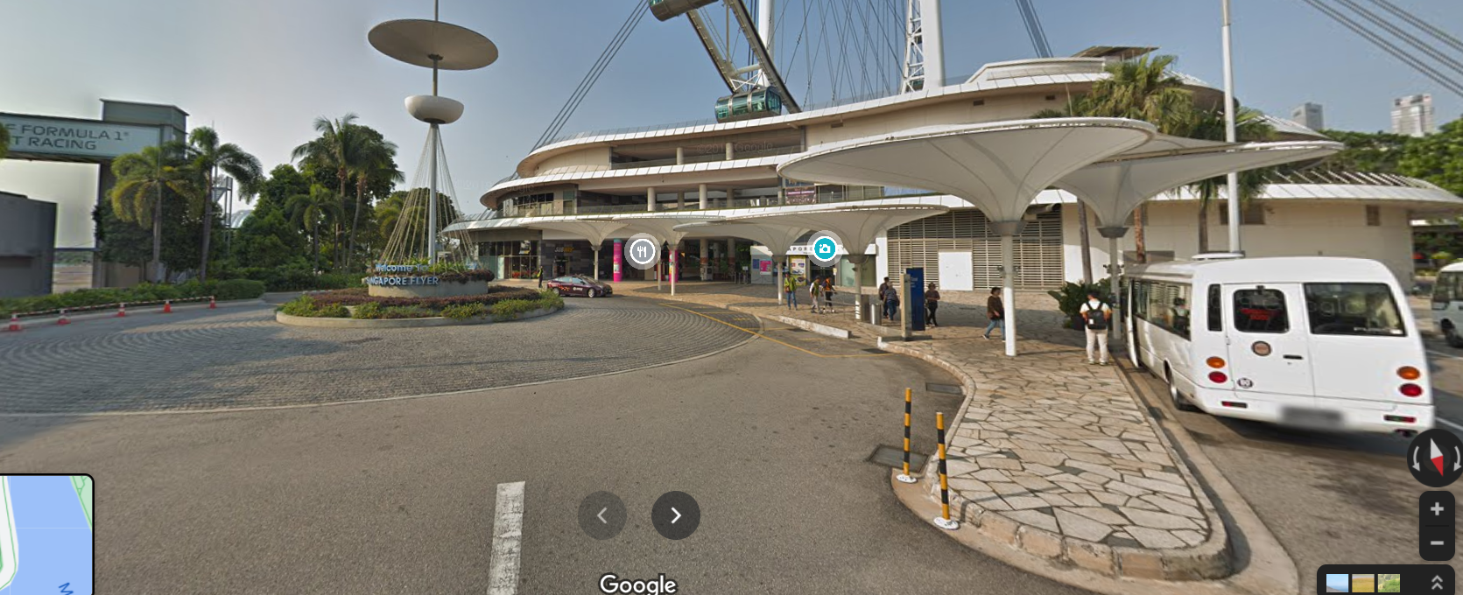
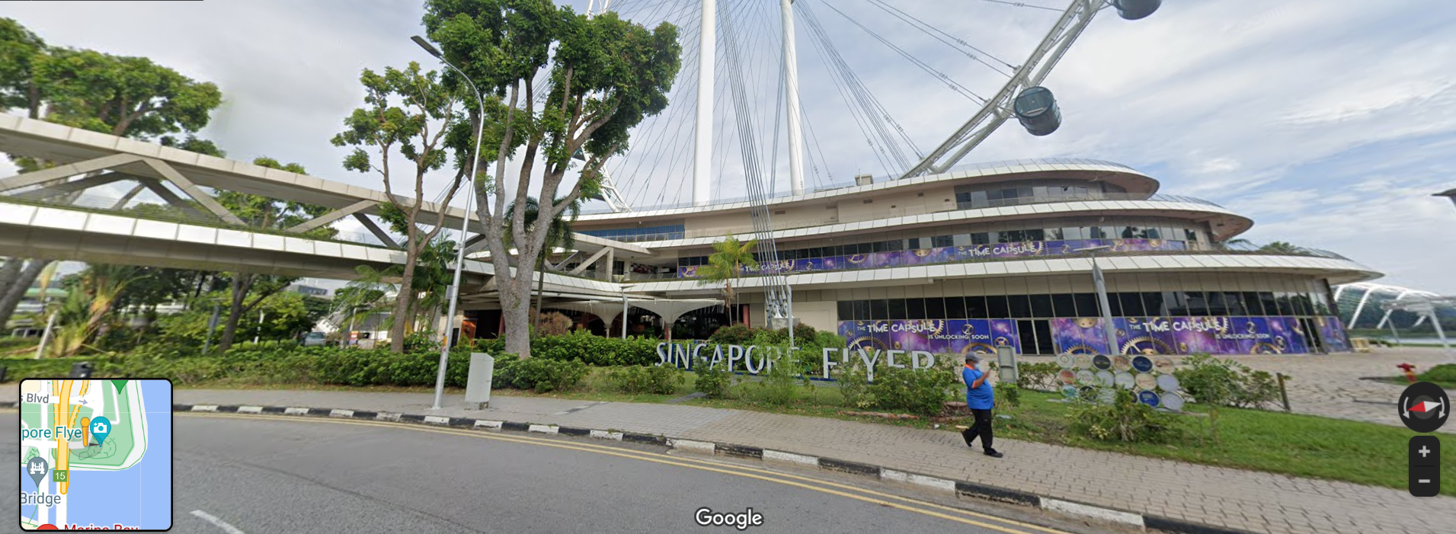
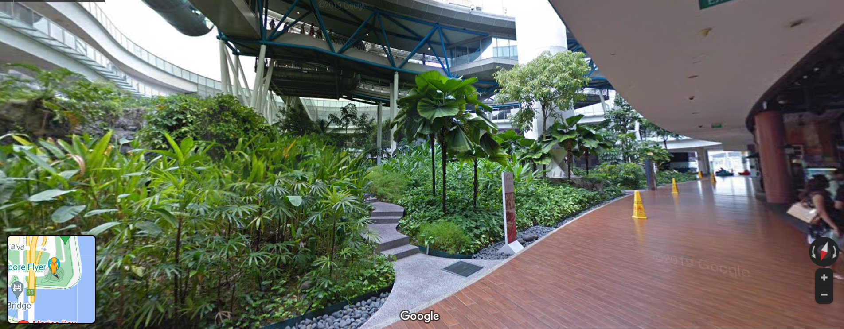
Marina bay Street Circuit (approach)
